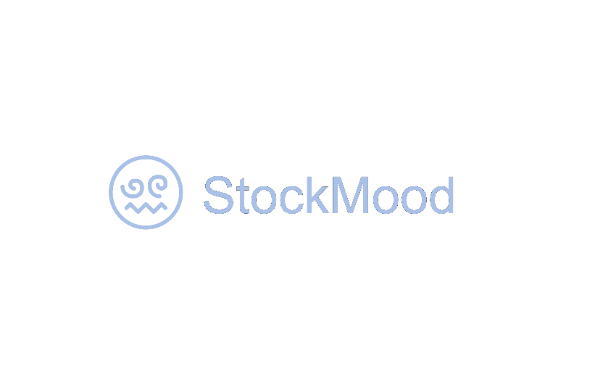

## StockMood is a smart platform that helps retail investors make informed, sentiment-aware decisions in the fast-changing Indian stock market. It tackles the risks of hype-driven investing—especially around nano and micro-cap stocks—by offering real-time sentiment insights, data-driven analysis, and valuation tools. Using NLP, machine learning, and traditional financial metrics, StockMood helps users cut through noise, spot real opportunities, and invest more confidently and responsibly.

**Fund Management Proposal for Equity Investment**

**Prepared for:**

Amarjeet Singh

3rd May, 2025

**Prepared by:**

Angad Singh Virdi

StockMood

**1. Objective**

The objective of this proposal is to provide a strategic and disciplined approach to managing your investments in equity markets. Our goal is to grow your capital over the medium-to-long term while managing risk through diversification, research-driven stock selection, and active portfolio monitoring.

**B. Stock Selection Strategy**

StockMood use a hybrid approach combining:

* **financial data analytics**
* **relative industry valuation**
* **sentiment analysis**

**Combining all 3 approaches, StockMood discerns growth stocks.**

**C. Diversification Strategy**

StockMood ensure sectoral and geographical diversification to minimize unsystematic risks. Portfolio will typically include:

* 10-15% (blue-chip stocks)
* 85-90% (mid/small/micro/nano-cap/high-growth stocks*)

**4. Risk Management**

* **Rebalancing:** Quarterly or as required
* **Volatility Monitoring:** Use of beta and standard deviation metrics
* **Sector Exposure Limits:** No more than 25% in a single sector
* **Liquidity Management:** Regular review of average daily volumes

**5. Reporting and Transparency**

You will receive:

* **Weekly/Monthly performance updates & portfolio reviews**

**6. Fees and Charges**

* **Management Fee:** Free**\***
* **Performance Fee:**

|  |  |
| --- | --- |
| **Return (%)** | **Fee ( of profits )** |
| 0-2 | NA |
| 2-20 | 50% |
| 20+ | 70% |

Note*: zero management fee for first 12 months, 2% of assets under management (AUM) thereafter.

**7. Expected Returns**

|  |  |
| --- | --- |
| **Time horizon** | **Expected return per month\*\*** |
| 0-3 months | 2-15% |
| 3+ months | 2-20% |

Note**: returns are subjected to normal market conditions barring wars, pandemics, natural calamities, etc.

**8. Conclusion and Next Steps**

StockMood believe this investment strategy aligns with your financial goals and risk profile. Upon approval, we will:

1. Finalize onboarding and share portfolio credentials
2. Provide continuous oversight and updates

Please review and share your feedback or approval to proceed.